Student: Toleubek Assiya
ID: 23B150271

Scenario: Online Bookstore Database
You are tasked with designing and querying a database for an online bookstore. The system needs to track:
- Books: each book has an ISBN, title, author, publisher, publication year, price, and stock quantity.
- Authors: authors have an ID, name, and birth year. (Note: a book may have multiple authors, and an author may write multiple books.)
- Customers: customer ID, name, email, address, registration date.
- Orders: order ID, customer, order date, total amount, status (e.g., 'shipped', 'pending').
- Order Items: details of each book in an order: quantity, price at time of order.

Part A: Conceptual Questions
Answer the following in a few sentences each:
- Explain the main differences between relational (SQL) and non-relational (NoSQL) databases. Give an example of a scenario where you would choose each type.
Relational databases store data in structured tables with rows and columns and use SQL (online bookstore with customers, orders, and books). Non-relational (NoSQL) databases store data in flexible formats such as JSON, documents, or key-value pairs and do not require a fixed schema (social media posts or product reviews where structure varies.).

- In the bookstore scenario, would you recommend a relational or a NoSQL database? Justify your answer.
A relational database is recommended for the bookstore. The system contains structured data with clear relationships between books, authors, customers, and orders. SQL databases also support joins, constraints, and transactions, which are important for maintaining accurate order and payment data.

- What are ACID properties? Why are they important for a bookstore's order system?
Atomicity: transactions are all-or-nothing
Consistency: data follows rules
Isolation: concurrent transactions don't interfere
Durability: committed data survives failures
These properties are important for a bookstore because when a customer places an order, the system must correctly update stock, save the order, and record payment. If something fails, the transaction should roll back to avoid incorrect data.

- What is a primary key? What is a foreign key? Give an example from the bookstore schema.
A primary key uniquely identifies each row in a table (Books.ISBN is the primary key of the Books table)
A foreign key is a column that references a primary key in another table (Orders.CustomerID is a foreign key referencing Customers.CustomerID).

- Why is it important to avoid data redundancy? How does normalization help?
Data redundancy means storing the same data multiple times, which can cause inconsistencies and increase storage usage (storing author names in the Books table repeatedly would duplicate data).
Normalization organizes data into separate tables and uses relationships between them (In the bookstore, authors are stored in the Authors table and linked using BookAuthors, avoiding repeated author information).

Part B: Database Design
Draw an Entity-Relationship (ER) diagram for the bookstore database. Include entities, attributes, relationships, and cardinalities. You can draw it on paper and scan/take a photo, or use any diagram tool. Then, write the relational schema (list of tables with columns and keys) in text format.
Expected tables:
- Authors
- Books (with a foreign key to publisher? We'll keep it simple: publisher as attribute)
- BookAuthors (junction table for many-to-many between books and authors)
- Customers
- Orders
- OrderItems
Ensure you identify primary keys, foreign keys, and any constraints (NOT NULL, UNIQUE, etc.).
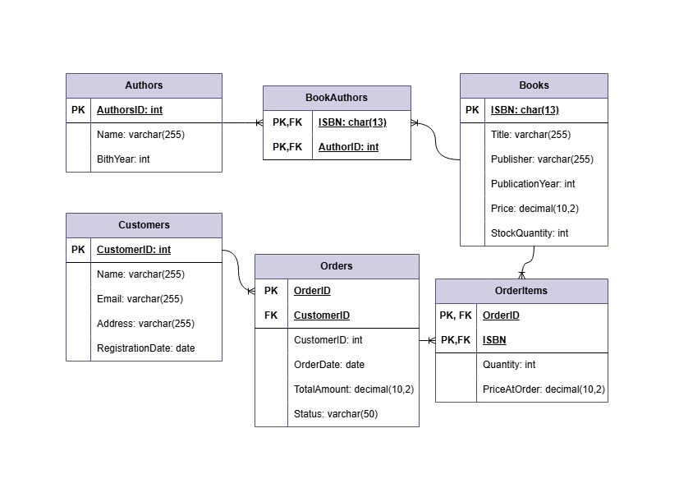

Part C: SQL Data Definition Language (DDL)
Write the SQL statements to create all the tables you designed in Part B. Include:
- Appropriate data types (e.g., INT, VARCHAR, DECIMAL, DATE)
- Primary key constraints
- Foreign key constraints with ON DELETE and ON UPDATE clauses (choose appropriate actions)
- Other constraints like NOT NULL, UNIQUE (e.g., email should be unique)
Execute these statements in a database (SQLite, MySQL, or PostgreSQL) to create your database. You can use an online SQL environment if you don't have local installation.
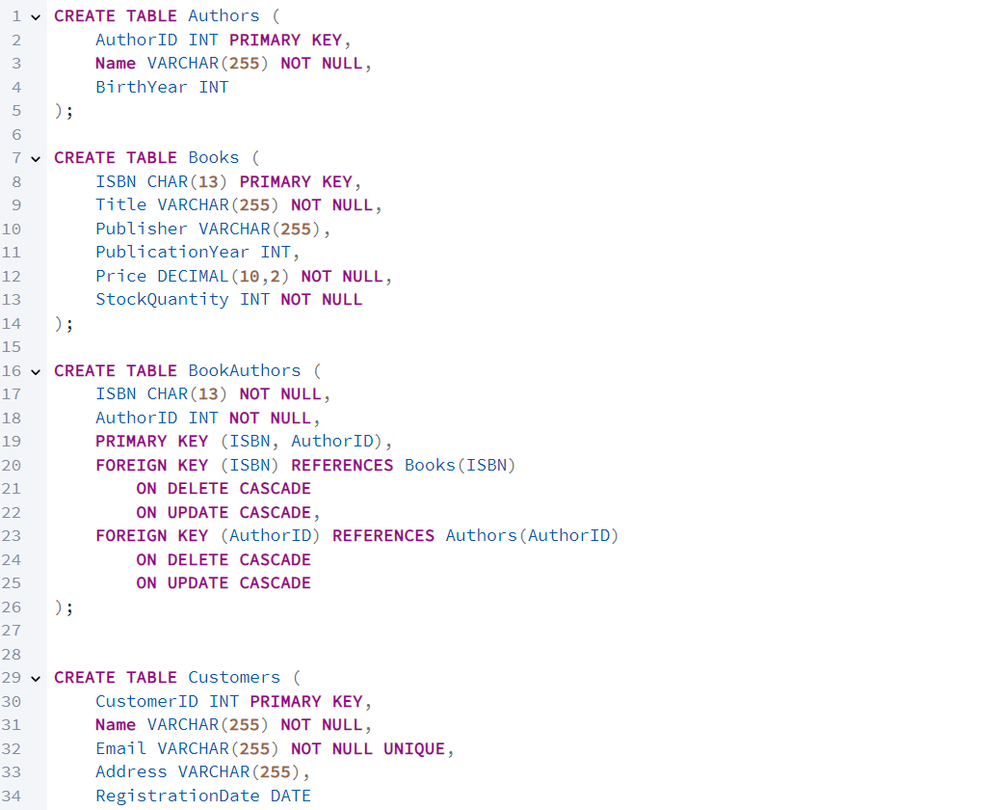
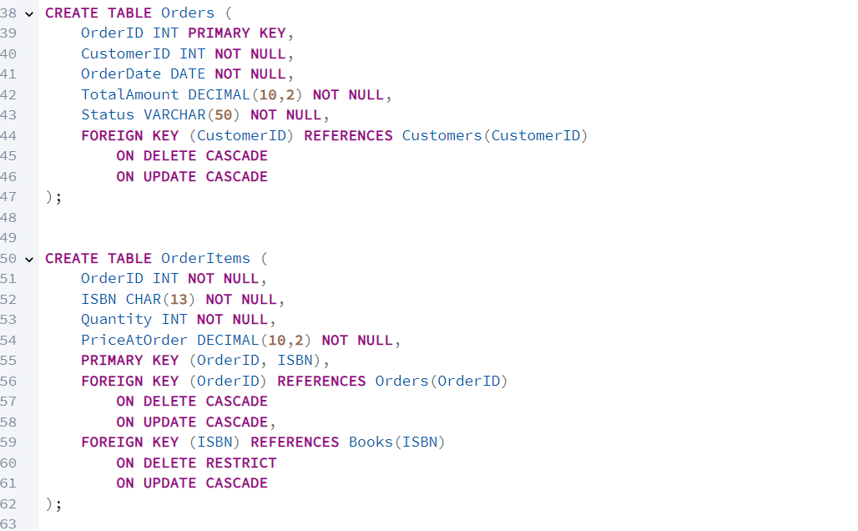

Part D: Populating the Database
Insert sample data into each table. Include at least:
- 5 authors
- 10 books (ensure some books have multiple authors)
- 5 customers
- 8 orders (with varying dates, statuses)
- Appropriate order items (each order should have 1-3 books)
Write the INSERT statements. You may generate realistic data (e.g., book titles, customer names). Ensure referential integrity is maintained (e.g., orders reference existing customers, order items reference existing orders and books).
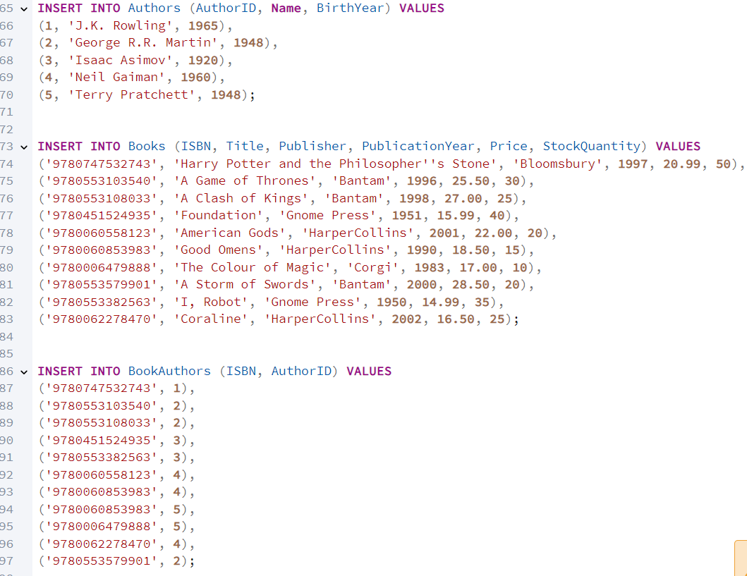
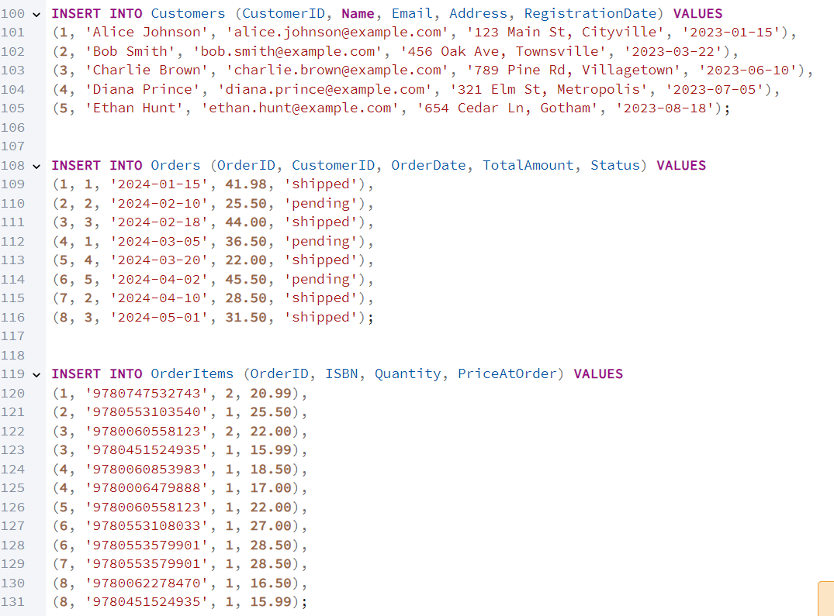

Part E: SQL Queries
Write SQL queries to answer the following business questions. For each, provide the SQL statement and the result (or screenshot of the result if you executed it).

Basic Queries
- List all books with their title, author(s), and price. (Hint: you'll need to join Books, BookAuthors, Authors)
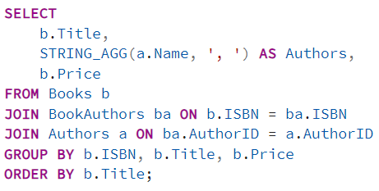
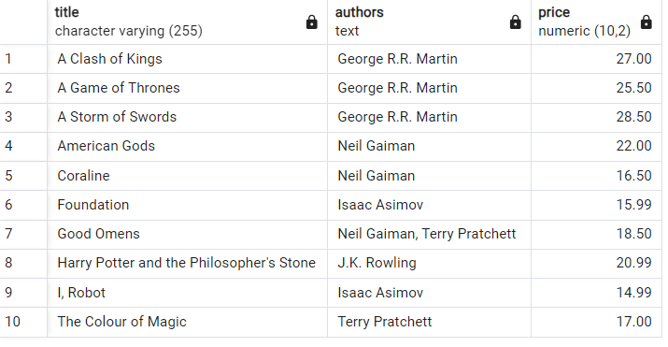

- Find all customers who registered in 2023.
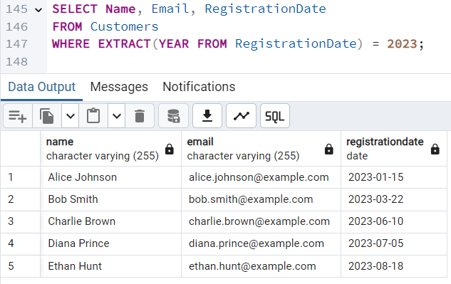


- Show orders that have a status of 'pending' and were placed in the last 30 days (use current date or a fixed date like '2024-03-01').
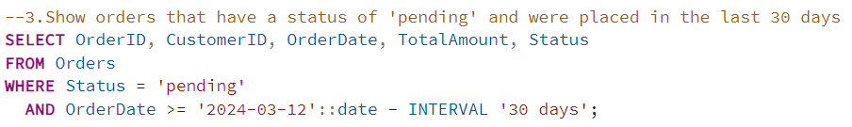
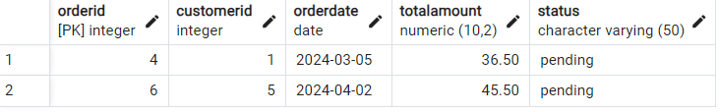

- Count how many books each author has written.
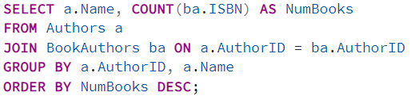
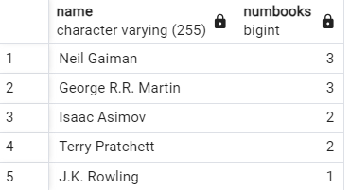

- Display the total number of orders placed by each customer, sorted descending.
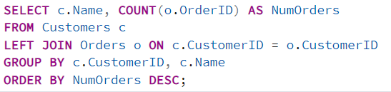
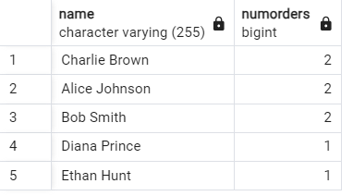

Intermediate Queries
- Calculate the total revenue generated from all orders (sum of total_amount from Orders table). (Make sure your total_amount is consistent with order items – you can either compute it from OrderItems or trust the stored total. For practice, compute it from OrderItems.)
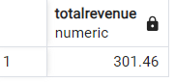

- Find the top 3 best-selling books by total quantity sold.
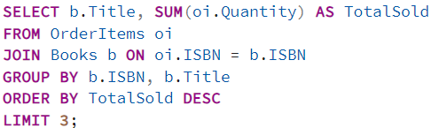
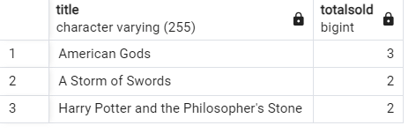

- List customers who have spent more than $100 in total across all their orders.
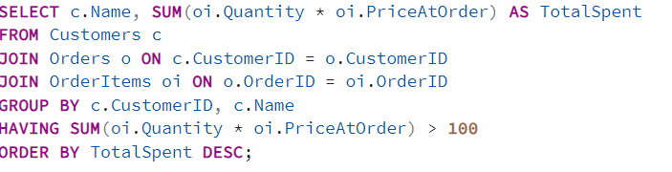


- For each month in 2024, show the number of orders and total sales. (If no data, use DATE functions to extract month/year.)
